Project Design Phase
Solution Architecture
Date | 18 june 2026
Team ID
Project Name | HOUSE RENT
Maximum Marks | 4 Marks
Solution Architecture:
The Solution Architecture of House Hunt defines how different components of the system interact to provide a seamless property search experience for users and efficient management capabilities for administrators. The architecture follows a MERN Stack approach, consisting of React.js for the frontend, Node.js and Express.js for the backend, and MongoDB for data storage.
The primary goals of the solution architecture are:
• To provide a centralized platform for browsing, searching, and viewing property listings online.
• To enable secure user authentication and role-based access for users and administrators.
• To facilitate efficient property, inquiry, and user management through an administrative dashboard.
• To ensure smooth communication between the frontend, backend APIs, and database.
• To allow users to search, filter, save favorite properties, and contact property owners or agents easily.
• To provide a scalable and maintainable architecture that can support future enhancements, additional property listings, and increased user traffic.
Example: Home Buying Hub application.
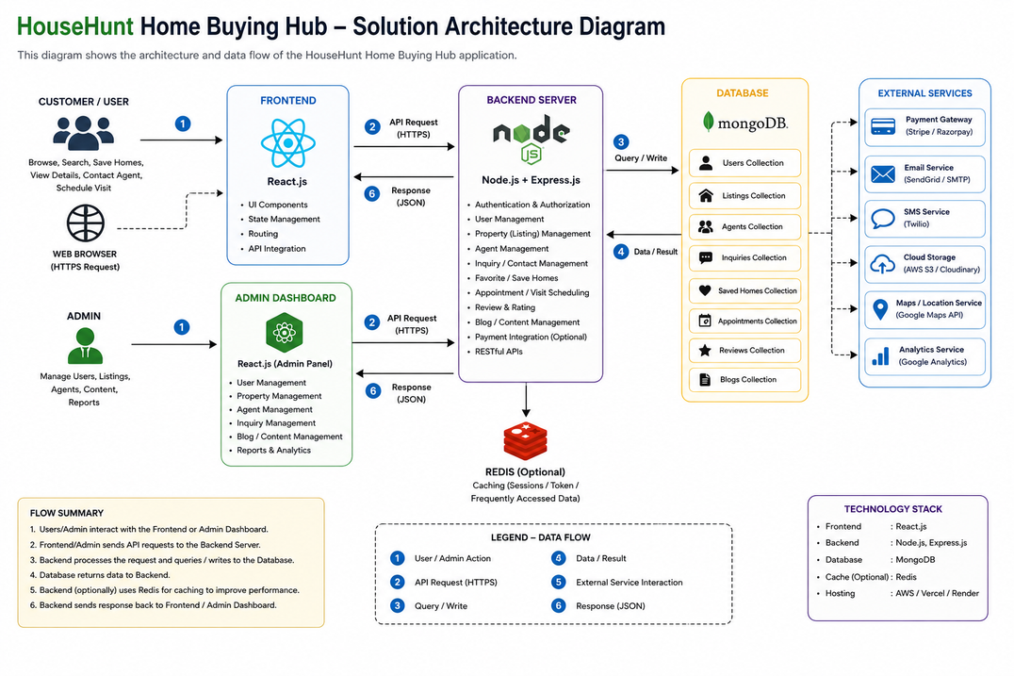
Figure 1: Architecture and data flow of the HouseHunt Home Buying Hub application.

